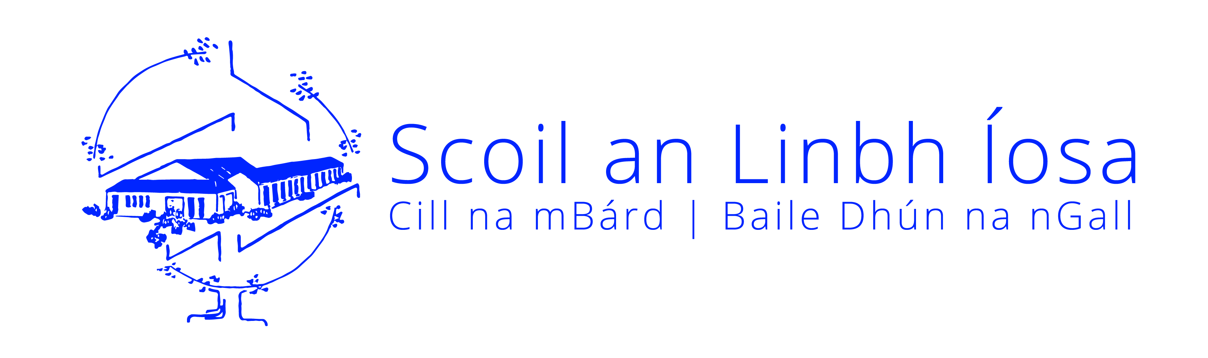

Scoil an Linbh Íosa,

Killymard,

Donegal Town,

Co. Donegal.

Tel. 074 9722752

e-mail: killymardschool@gmail.com

Web Address: www.killymard.com

Application Form for Admission

Please refer to our Admissions Policy on our school website www.killymard.com

Please attach a Birth/Adoption Certificate and Baptismal Certificate (if applicable)

Personal Details

*Class and enrolment date: ____________________________________________________

*Child’s name: ______________________________

* Birth Certificate Forename: ___________________ *Birth Certificate Surname: __________________
(if different from above) (if different from above)

*Child’s PPSN: ___________________________ *Mother’s Birth Cert Name: ______________________

*Date of Birth: _____________________ *Male  Female 

*Child’s address: _____________________________________________________ *Eircode____________

*Nationality: ____________________________

*First Language: ______________________________ (i.e. language spoken at home)

Parents’ names: __________________________________ and __________________________________

Occupations: __________________________________ __________________________________

*Religious Denomination: __________________________________________________________________

*Special category data:

To which ethnic or cultural background group does your child belong (please tick one)?
(Categories based on the Census of Population)

White Irish □ Irish Traveller □ Roma □ Any other White Background □
Black or Black Irish - African □ Black or Black Irish - Any other Black Background □
Asian or Asian Irish – Chinese □ Asian or Asian Irish - Any other Asian background □
Other (inc. mixed background) □ No consent □

Contact Details

Telephone Numbers: Your child’s doctor:
Home: __________________________ Name: ___________________________________
Mother’s work: __________________________
Mother’s mobile: __________________________ Tel no. __________________________________
Father’s work: __________________________
Father’s mobile: __________________________
Other contact nos. _____________________________________

Mother’s e-mail address: __________________________
Father’s e-mail address: __________________________

Education Details

*Was this child in pre-school education or a childcare setting? (Applicants for Junior Infants only)
Yes No

Name of playschool if yes above: ____________________________

Name of previous primary school attended: ____________________________ Class : _________________

Sibling(s) attending or having attended Scoil an Linbh Íosa: _________________ __________________

Special Education & Medical Details

If your child has special educational needs, please give details:
___________________________________________________________________________________________________________________________________________________________________________________________________________________________________________________________________________________________________________________________

If your child has any medical / health problems, please give details (please see Administration of Medicine Policy on our school website):
___________________________________________________________________________________________________________________________________________________________________________________________________________________________________________________________________________________________________________________________

Other Information

Does any Legal Order under Family Law exist? Yes No
(If yes, you will be contacted by the Principal)
Is there any person into whose custody the child should not be given? Yes No
(If yes, you will be contacted by the Principal)

Signed: ____________________ _________________________
Parent/Guardian Parent/ Guardian

Date: ______________________ __________________________

NOTE:

Please confirm your consent for sharing all answers to questions with an * on our Primary Online Database (POD) as requested by the Department of Education and Skills (DES) by signing below. For further information on POD please see https://www.education.ie/en/Publications/Statistics/Primary-Online-Database-POD-/

I give my consent to share all information with an * on POD

Signed: ___________________________ Date: _____________________________

School Policies

I/We have read, and understood, the school’s Code of Behaviour, Anti Bullying and Internet Acceptance Usage Policy which are available to view on our school website www.killymard.com under Policies and will ensure that my/our child, named overleaf, will abide by them. I/we will co-operate with the staff and support the ethos of Scoil an Linbh Íosa. I/We confirm that all the above details are correct.

Signed____________________________ Date ___/___/______

Signed: ___________________________ Date ___/___/_____

Have you attached: Birth Certificate (original) Baptismal Certificate

GDPR Policy / Statement:

Please tick boxes below confirming your acceptance of the following:

Use your email address for communication purposes?
Use your mobile phone number to send you SMS / Aladdin alerts?
Use your mobile phone/landline number to call you.
If you are happy to have your child’s photograph taken / video taken
as part of school activities and included in all such records,
tick here

Please confirm your acceptance / compliance of this policy by signing below.

Signatures: ________________________________________ Date: __________________
________________________________________ Date: __________________

Parental / Guardian Permission Form

Please circle Y / N below

Parental Permission
Do you give permission to administer basic first aid (e.g. putting on a plaster) if your child has an accident at school/games/school tour? If an accident is of a more serious nature, the school will contact Parent/Guardian. | Y | N
I/We give permission for my/our contact details to be uploaded to the school *Aladdin system. *(School admin software used for the majority of communications for parents/guardians). | Y | N
I agree to contact the school immediately if I change my address, telephone number or email address as these details are essential for contact with Parents/Guardians via Aladdin. | Y | N
Educational / Diagnostic Tests
During your child’s time in Scoil an Linbh Íosa, it may be necessary from time to time for teachers to carry out educational diagnostic testing with your child on an individual basis in order to help them in their educational development. I give permission for any screening/diagnostic tests to be carried out with my child. | Y | N
Absences
I understand that the school must report to Túsla if a child is absent from school for 20 days or more and that if a child is absent for a prolonged period but without explanation and the Parents/Guardians cannot be contacted the school will contact the relevant authorities. | Y | N
Child Protection and Welfare
I understand that should the school have reasonable cause for concern regarding my child’s wellbeing/safety or if my child discloses any form of abuse, the school is bound to inform the HSE. | Y | N

